**Project Report – Team 11**

Product Vision: Splatoon 2 but with cars

○ Actual vs Planned Project schedule and timeline of task breakdown

Project Schedules & Task Breakdown

|  |
| --- |
| > Planned |

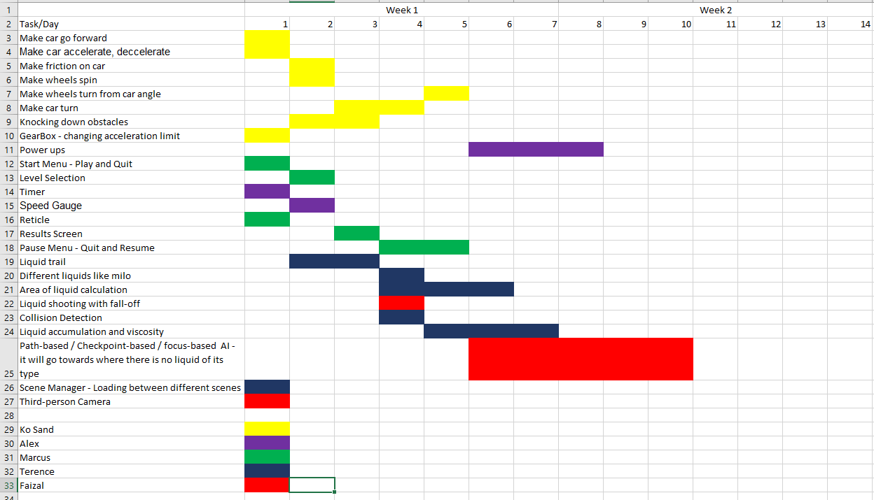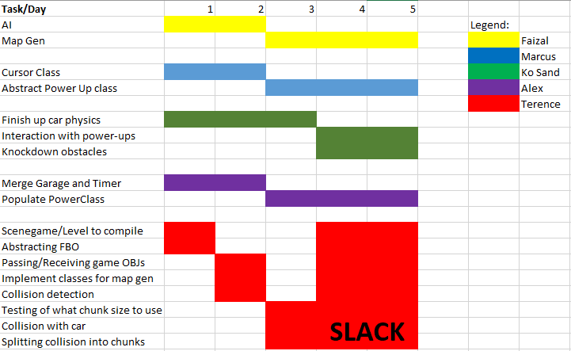

|  |
| --- |
| >Actual |

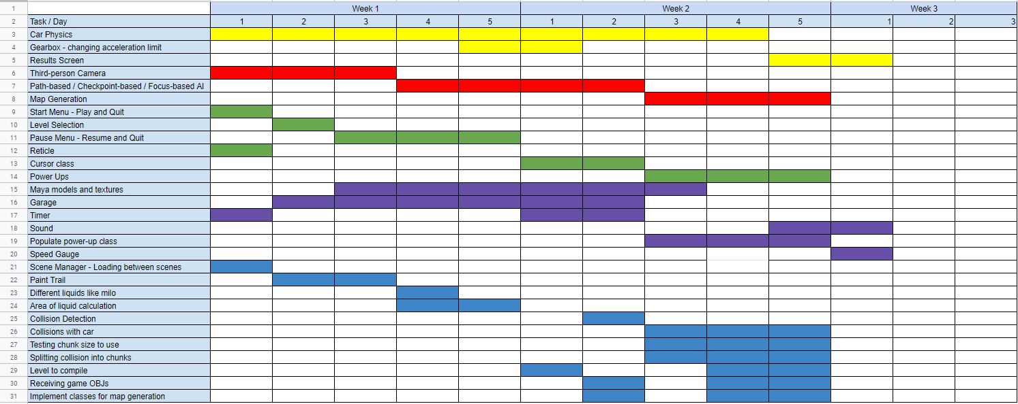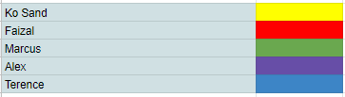

Screenshots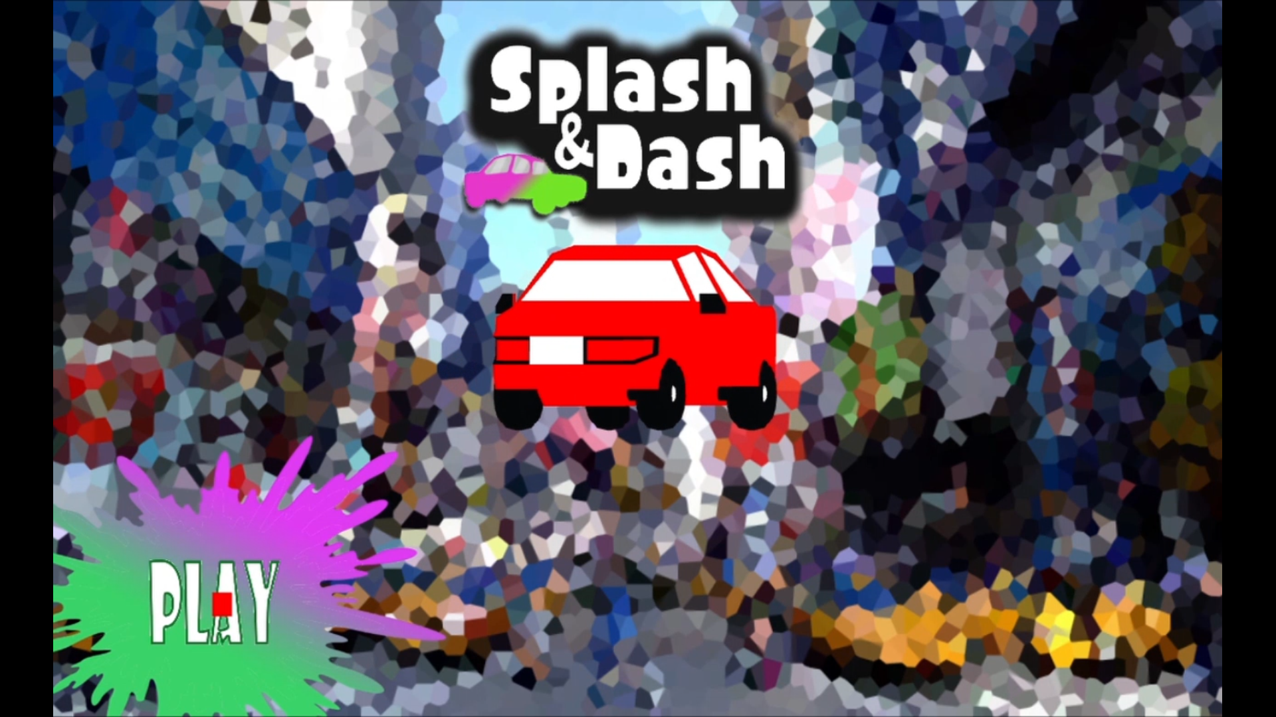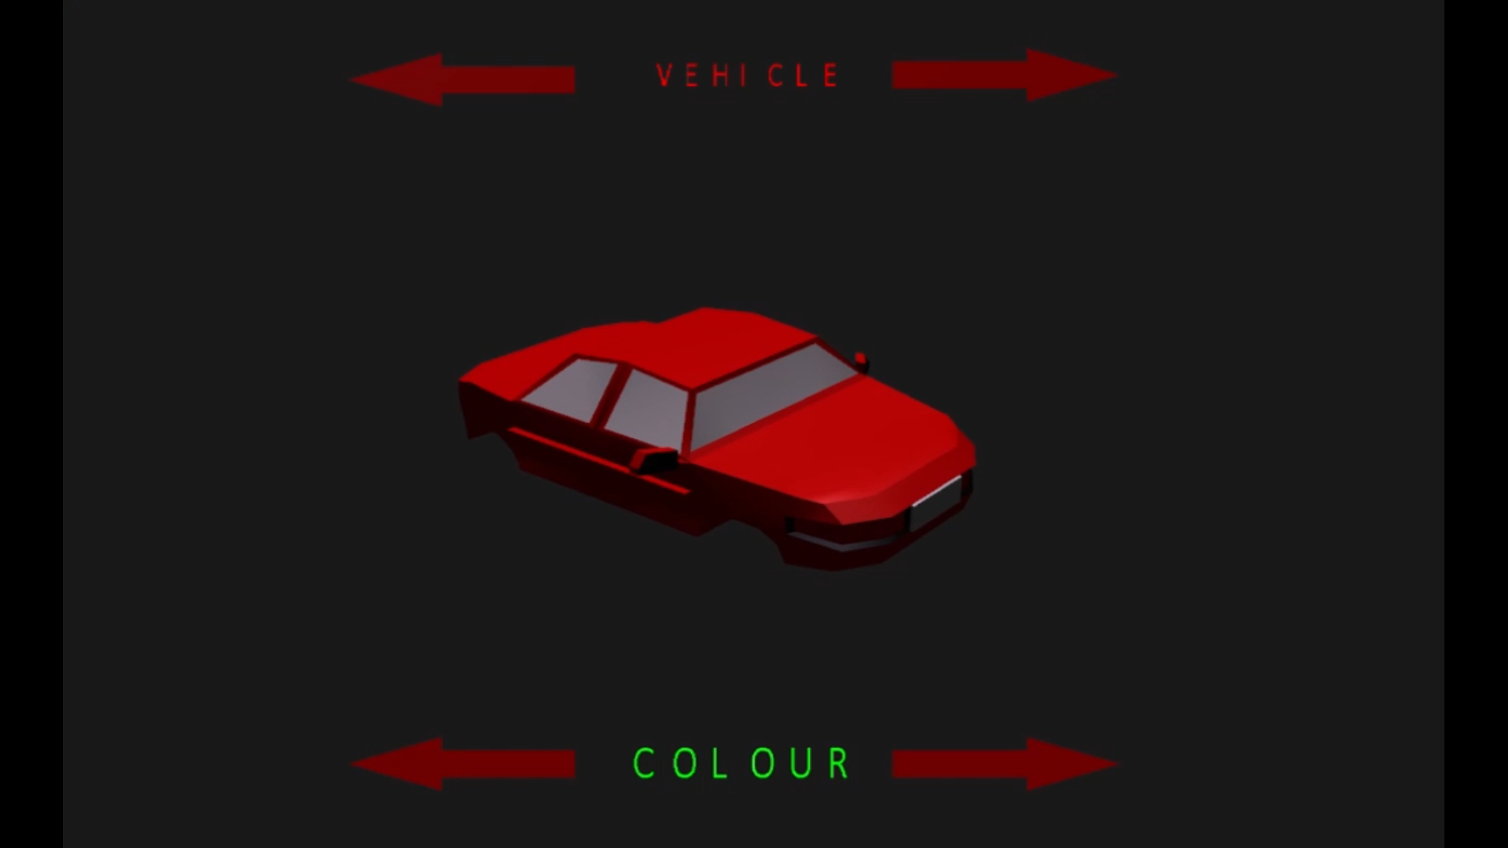

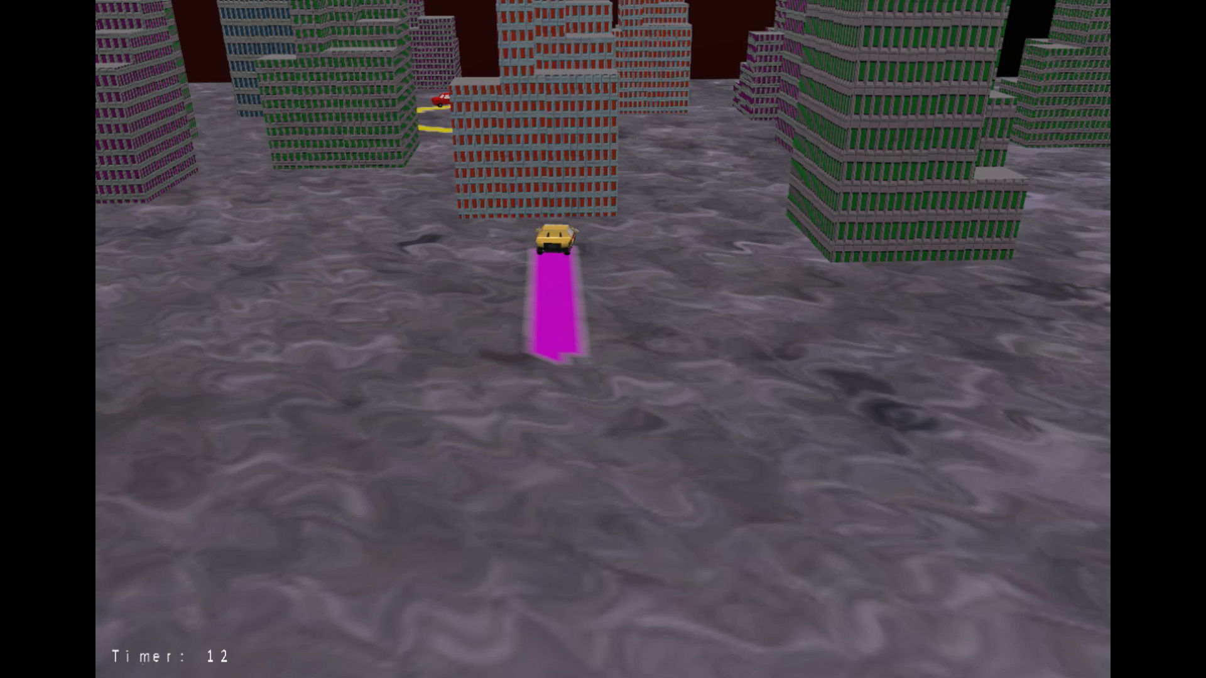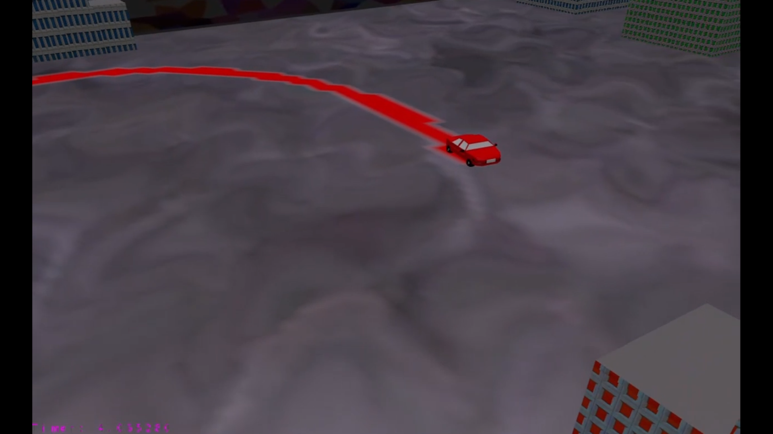

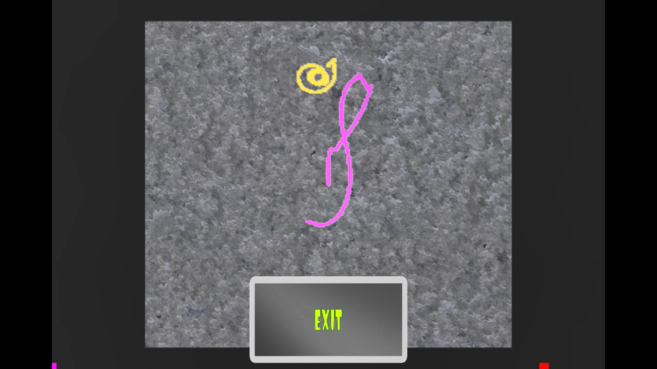

Description of Features

|  |  |
| --- | --- |
| Feature | Description |
| Car Physics | Can move.  Car uses kinematics we learnt from Game Physics to move around the scene |
| Scene Management | Can switch between scenes, and easy to develop new scenes  Use of inheritance, polymorphism and SOLID to abstractify the scenes, allowing us to easily work in different scenes |
| Collision Detection & Resolution | Can collide in the xz plane with any convex collider in any (xz) orientation  Use of algorithms - Collision detection with GJK and resolution with EPA (see technicalities), also uses singleton pattern so that only one object exists. |
| Paint | Can paint over textured meshes and calculate the coverage of paint on the mesh.  Paint uses modified fragment shader to render, and uses grid-cell splitting of map to reduce performance impact |
| A.I. | Can move like player (same physics), can move somewhat intelligently  Uses inheritance and define input->output behaviour to move around in the scene. Kind of like an using an interface(?), in that it uses the car base class to define its movement, but unlike the car it moves with a different set of inputs. |
| Collectibles / Power-ups | Can collect and apply effects on any gameobject  Uses inheritance and polymorphism to achieve varied behaviours |
| Vehicle Customization  (Colors & Decals) | Can change color/texture of car, and can customize a texture in-game to apply as a decal on the car. |

Technicalities

Explanation for features

|  |  |
| --- | --- |
| Feature | Technical Description |
| Car Physics | In short, we use kinematics to define realistic physics, up until the wheels.  It is implemented through a RigidBody base class, in which Vehicle inherits from, which Car then inherits from.  Car defines the wheel behaviour (to roll or not), while Wheel class defines how the wheel rolls, according to angular kinematics  Rigidbody defines how the *suvat* of the car changes, applying the kinematic equations, while the vehicle class defines the controls of the car, implementing Newton’s Second Law *F = ma*, and angular kinematics for turning of the car.  Static friction, Brake friction, and Kinetic friction are also taken into account for the kinematics of the vehicle. |
| Scene Management | All actual usable scenes inherit from a base scene class, which defines rendering, init, update, and exit behaviour, thus abstracting all opengl calls within the base class.  The base class also defines rendering of GameObjects, which store their transform data internally, thus hiding the model stack manipulation from inherited scenes.  The base scene class also defines two important functions:  RequestChangScene and RequestDontDestory.  These allow changing between scenes and enabling gameobjects to not be lost between scenes, allowing us to split up our game into multiple scenes for smaller individual scenes |
| Collision Detection & Resolution | Implemented in a singleton CollisionHandler class, which defines two main functions: CheckCollision and ResolveCollision, using GJK and EPA respectively.  Detection is done with Gilbert-Johnson-Keerthi (GJK) distance algorithm - “a method of determining the minimum distance between two convex sets”, using the Minkowski difference (sometimes referred to as Minkowski sum).  Basically, we try to construct a simplex (simplest shape) to surround the origin; if it succeeds then there is collision  GJK has been implemented for 2D and 3D, but 3D produces some false positives in the positive yz diagonals  In GJK, the triple cross product taught in Diploma+ Analytical Geometry came in use :)  Resolution is done with Expanding Polytope Algorithm (EPA), a complement to GJK to determine penetration distance and direction of two convex hulls, also using the Minkowski difference.  It works by expanding the simplex from GJK to find the closest point and its distance from origin, which gives the penetration vector  EPA has been implemented for 2D and 3D, but 3D is unstable and has many numerical precision errors  Due to insufficiency in the 3D implementations (and lack of time to improve it), we have used 2D collision in our latest iteration. |
| Paint | For painting over meshes, it has two main points, rendering and optimisation  It works by rendering a high-poly transparent mesh over the existing textured low-poly mesh. Given a vector3, we search the vertex buffer object for the nearest vertices and change the vertex color to the specified color. This effectively makes a paintable canvas.  However, depending on scale and range of the vertice search, performance is severely impacted due to the sudden load on the CPU and that one frame takes a lot longer to process  This is where the optimisation comes in. We reduce the time and space complexity by reducing the number of vertices to search, and making sure to only search once, resulting in O(n) execution with n about 12-30 data per frame. This is done by a O(m^2) generation of a grid of cells. Each cell store the vertices enclosed in them, and hence when searching for vertices we only search the cell the vector3 is in and the adjacent cells which are pre-stored in each GridCell object.  For calculating coverage, this is done by rendering the paintLayer to a different framebuffer object, and reading the bounded texture of the framebuffer, splitting each pixel into its rgb component. By disabling light on the mesh(which messes with the vertex colors), we can directly read the vertex colors as rendered to the framebuffer object. Then, by looping through the pixels, we can check with the reference color and allocate a count, then do a division to calculate percentage. The benefit of this method is that it is independent on how i render my meshes. The flaw is that it cannot be done per-frame because it takes too long. This can be optimised by reducing the amount of pixels by dropping the resolution, which may or may not affect precision of the calculation; Or it can be run asynchronously / over multiple frames. |
| A.I. | Inherited from Vehicle class, which defines the movement and physics of the car  The AI class defines the behaviour in which these movements are carried out, by using input data based on its direction and its target direction vector.  It chooses its target direction based on the adjacent empty cells, preferring those that are covered in the opponent’s paint color. |
| Collectibles / Power-ups | Implemented through a base abstract Collectible class. The base class defines pure virtual functions in which the derived must define.  Thus each collectible can be collected and apply an effect to a specific gameobject, through Polymorphism. |
| Vehicle Customization  (Colors & Decals) | Changing of textures in the scene is made possible by pre-loading in textures and storing them in an unsigned array  Decals are made possible by rendering of a mesh to a different framebuffer, and writing that framebuffer object’s color attachment to a tga (this feature was implemented for paint calculation, see above), and then loading in that tga, storing in the gameobject's textures array. Writing of tga header was referenced from the web and the provided LoadTGA.cpp |

UMLs + additional explanations

|  |
| --- |
| Framework  Application provides the input detection for each scene, and handles the actual switching of scenes  SceneManager stores all scenes to change from and to, and delegates the changing of scenes from each scene to Application via PollForSceneChangeEvent()  Each scene handles the initialization and frame-updates of opengl related functions.  Derived scenes need only to override the virtual functions.  MeshBuilder handles generating of meshes, while meshes handles the opengl rendering pipeline  GameObject acts as a service in between Mesh and Scene, where it stores the transform to be applied to the mesh, and any other extra information for the scene to use when rendering that mesh/object  Scene also aggregates camera and light, in which the derived scenes can override  Camera is an abstract class in which the update function can be overridden.  The helpers refer to small files which contain helper functions for use in the framework |

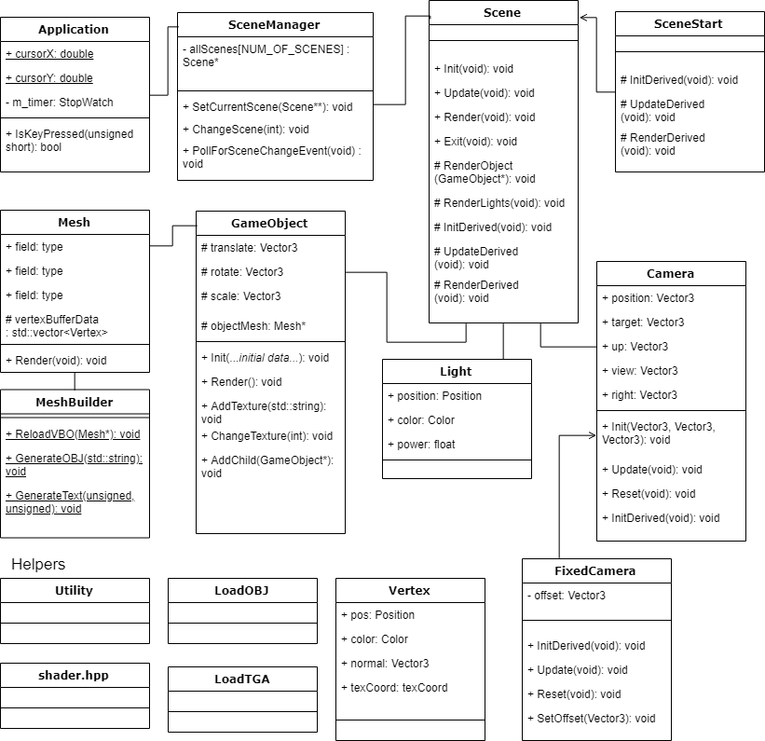

|  |
| --- |
| Collision  Collidable aggregates a Collider object, and handles the defining of the hullPoints in collider.  CollisionHandler is a singleton class which compares two collidables and handles the collision. (RigidBody is derived from Collidables) |

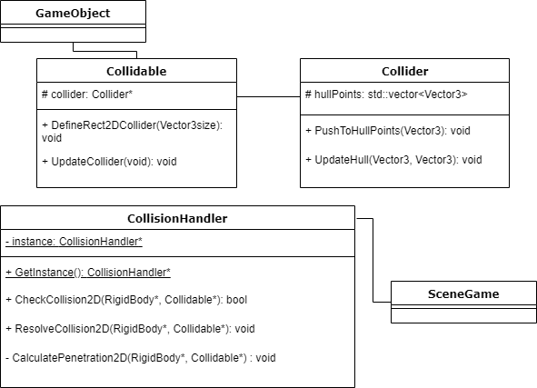

|  |
| --- |
| RigidBodies  RigidBody handles the kinematic calculations for the moving object, while Vehicle handles the input of forces which then affects the kinematics.  Car inherits from Vehicle and defines the number of wheels  Each wheel defines the way it rolls, handling its own angular kinematics |

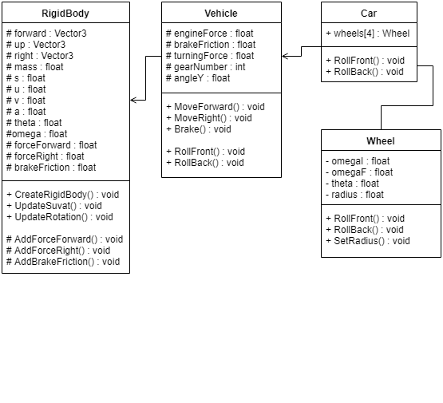

|  |
| --- |
| BuildMap  BuildMap helps to get random locations within the Grid chunks of the Grid. It sets areas which are occupied on the map to ignore those places when selecting a Grid chunk randomly to generate a building on.  (Example: The point at which the car spawns is set to occupied so a building will never be generated on that location.)  Within it, it also has functions that randomise the type of building generated, texture and scaling of the buildings. This is so that, everytime the game begins, the map looks as randomised as possible. It also reads the vertices of cells within the grid to get the next location for the AI to move towards. |

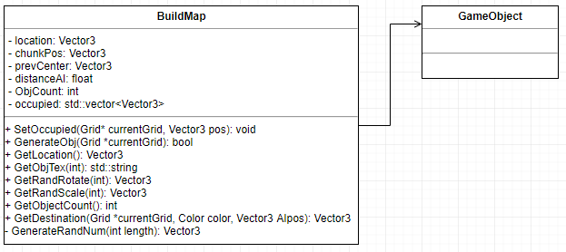

|  |
| --- |
| AI  AI constantly tracks its location and checks if its within range of its destination, once it has reached, a new destination will be passed to the AI and it will move towards the new destination based on the physics that has been implemented (Inheritance). Within checking to move, it also checks if it has to turn, and turn when it needs to. |

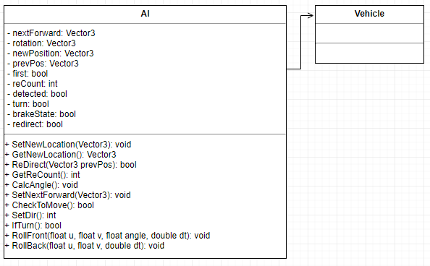

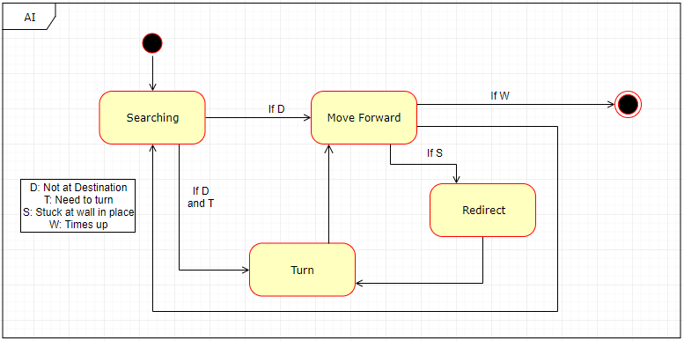

|  |
| --- |
| Paintables  Paint is an object that stores color and percentage  Paintable is a derived GameObject that has the additional properties of being able to change color and storing of the object’s vertex buffer object  The static CalculateCoverage function is a helper/utility function not specific to any paintable object.  Grid stores all the cells (and chunks for Map). which stores vertices from the vbo within the cell’s coordinates.  Each GridCell can search its vertices and change color of those in range of a given Vector3 |

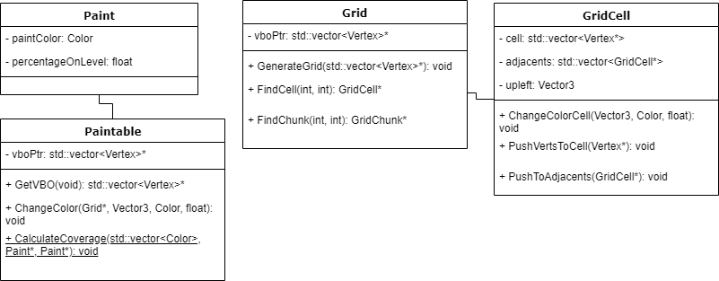

|  |
| --- |
| UI Stuff  Cursor and Button both inherit from GameObject as they need to be rendered in the game scene.  We store the button objects in allButtons vector and CheckHover() is run on all the buttons to see if the cursor is hovering over any of the buttons.  CheckHover() checks if the cursor is within range on any of the buttons, if so it will set Hover to true for the button that cursor is on.  When left mouse button is clicked and Hover is true, onClick will be set to true. An action will be carried out. |

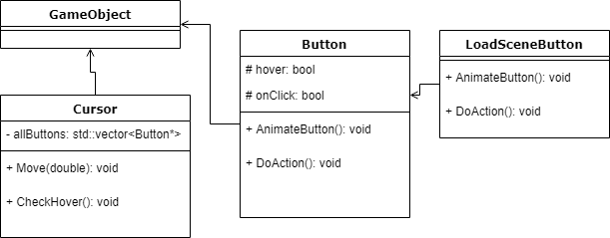

|  |
| --- |
| Collectibles  CheckAbsorption checks if the Vector3 position that is passed in is within range of the Collectible object, if so , pickedUp will be set to true and activeTime will be set to maxActiveTime, ApplyEffect() checks if pickedUp is true before counting down the activeTime of the powerup and applying the powerup effect to the GameObject. |

